Web Content Accessibility Guidelines (WCAG) 2.0 Compliance:
Considerations for CAUL

INTRODUCTION
Equal access to website resources is a legal requirement in Australia. The Disability Discrimination Act (Cth) (Austl.) 1992 (DDA) covers the provision of information and online services. Equal access to these information sources and services is required under this act where it can “reasonably be provided”. The DDA can be applied to any information or goods, services or facilities provided through the internet whether the service is provided for payment or not. It should be noted that web users with a disability who cannot access a website can, and do, take their cases to the Human Rights Commission (Australian Human Rights Commision, 2010).
BACKGROUND
Anyone operating an Australian website must be compliant under the World Wide Web Access: Disability Discrimination Act which is administered by the Australian Human Rights Commission (Australian Human Rights Commision, 2010). This includes Australian Government Agencies who are required to be compliant under the Web Accessibility National Transition Strategy. This Act is largely built around a set of standards developed by the World Wide Web Consortium (W3C). The WC3 created a working party to establish accessibility guidelines to assist developers when creating online resources. Web Content Accessibility Guidelines (WCAG) 2.0 is the result of this effort and is now the International standard for accessible online content ISO/IEC 40500:2012 (International Organization for Standardization, 2012).
COMMENTARY
In November 2009, the Online and Communications Council (OCC) endorsed WCAG 2.0. This requires all Australian, state and territory government websites created after July 2010 to conform to the guidelines to meet WCAG 2.0 Level A by December 2012. Federal Government organisations are covered under the Web Accessibility National Transition Strategy (NTS). These government agencies must comply with Level A by December 31, 2012 and AA by December 31, 2014 (Australian Government Information Management Office, 2010). There has been significant debate as to whether Universities are obliged to follow the mandate of the Web Accessibility National Transition Strategy. A strictly legal reading of the situation indicates that Universities are not required to meet the NTS timelines. The Human Rights Commission’s advisory notes indicate that compliance with the guidelines equates to compliance with the DDA. Universities are covered under the DDA so it is a significant risk not to assume the advisory notes are relevant to Universities. The view on this will be dependent on individual University tolerance for risk. The advisory note states the following:
•Non-government websites and web resources whose development commences after July 1 2010 should comply with WCAG 2.0 to a minimum of AA-Level conformance;
•Existing non-government websites or web resources that undergo substantial change in the period July 2010 – December 2013 should comply with WCAG 2.0 to a minimum level of AA conformance;
•All existing non-government websites and web content should comply with WCAG 2.0 to a minimum level of AA conformance by December 31 2013.
(Australian Human Rights Commision, 2010, Section 4.2 Transitioning to WCAG 2.0)
These dates align with the NTS timelines. The NTS is currently in Phase 3 – Implementation (See Fig. 1.0 in appendix A).
The Australian Government has endorsed the Web Content Accessibility Guidelines (WCAG 2.0) as the standard for website accessibility for all government websites. It is a mandatory requirement as outlined in the Australian Government Web Guide (Department of Finance, 2012). Conformance is required on all websites owned and/or operated by government. This includes external (public-facing or private) and internal (closed community) sites. That is, conformance is required for all internet, intranet and extranet sites. The requirement also includes all documents and applications hosted on these sites.
The procurement of 3rd party resources is also covered and is of considerable interest to CAUL and its role in negotiating consortia deals with publishers of online resources. “The Web Accessibility National Transition Strategy (NTS) encourages agencies to review their procurement policies to ensure the purchase of more accessible goods and services” (Australian Government Information Management Office, 2010, 2013). Importantly for our Library operations is a consideration for the implications of these requirements, the NTS requires Libraries to ensure 3rd party products and services procured and provided via Library websites are accessible. Libraries should include the need for an accessible product through procurement and licencing documents by seeking conformance with Web Content Accessibility Guidelines 2.0. In addition WCAG 2.0 compliance should be recommended as part of the product assessment practice in our Libraries. If a supplier cannot provide an accessible product, alternatives are required or there is a need to ensure that there is adequate information about the link to warn of possible accessibility issues and provide alternative pathways (Australian Government Information Management Office, 2010, p.22).

The University of Western Sydney (UWS) library is currently auditing all electronic resource providers requesting an update on their WCAG AA accessibility compliance. To date the results of the 111 online providers surveyed, are as follows:

- 24% Yet to respond;
- 28% Audit/Compliance in progress;
- 24% Are seeking further information;
- 16% Indicated they comply with WCAG 2.0/Section 508 of the VPAT;
- 7% Do not comply/not interested in WCAG 2.0.
This information will be made available to all CAUL members once completed or on request.

Recommendations
Although it is likely that Universities are not covered under the NTS and no mandatory actions are required, it can be viewed as a social responsibility and good practice for our libraries to consider WCAG 2.0 compliance in the provision of our services.
The following recommendations are made to CAUL.
- That CAUL procurement/licencing procedures are updated to include information from vendors in relation to WCAG compliance.
- That CAUL request WCAG compliance information when presenting CAUL deals to member
- That data on WCAG compliance be made available via the CAUL website.
- That CAUL raise awareness of WCAG requirements in relation to online access with specific focus on the procurement/licencing process within member Libraries.

David Howard
University Librarian
Edith Cowan University
Updated 27 August 2014

Appendix A
Fig 1.0 WCAG National Transition Strategy
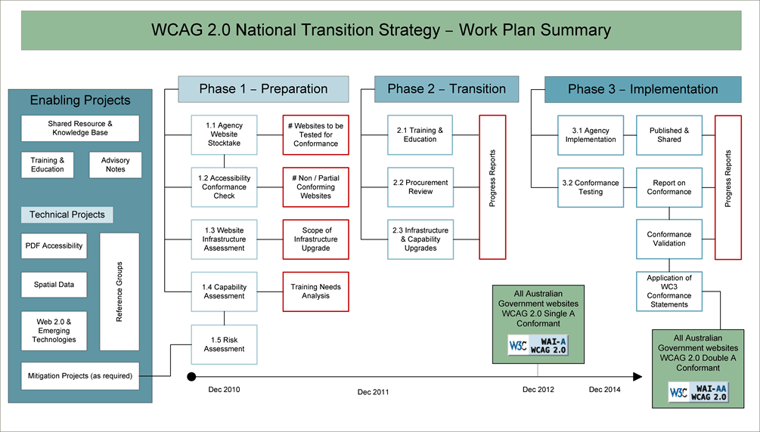
(Australian Government Information Management Office, 2010, p.25
Appendix A
Fig 2. Compliance Targets
State / Territory | Compliance Level | Requirement | Due Date
Vic, ACT,NSW , NT | WCAG (A) | Mandatory | 31 Dec 2012
 | WCAG (AA) | Mandatory | 31 Dec 2014
QLD | WCAG (A) | Mandatory | 31 Dec 2012
*Excludes Guideline 1.2 | WCAG (AA)* | Mandatory | 31 Dec 2014
SA | No specific dates set
WA | WCAG (A) | Mandatory | 31 Dec 2013
 | WCAG (AA) | Preferred | 31 Dec 2013
Tasmania | WCAG (A) | Mandatory | 31 Dec 2012
 | WCAG (AA) | Recommended | 31 Dec 2014
(Media Access Australia, 2012)

Bibliography

Australian Government Information Management Office. (2010). Web Accessibility National Transition Strategy. The Australian Government's adoption and implimentation of Web Content Accessibility Guidlines version 2.0 (WCAG 2.0). Department of Finance and Deregulation,
Retrieved from http://www.finance.gov.au/publications/wcag-2-implementation/docs/wcag-transition-strategy.pdf.
Australian Government Information Management Office. (2013). Accessibility for Web related ICT Procurments: Specifying accessibility requirements in procurement documentation - February 2013. Department of Finance and Deregulation Retrieved from https://webguide.govspace.gov.au/files/2014/03/Accessibility-for-Web-related-ICT-Procurement.pdf.
Australian Human Rights Commision. (2010). World Wide Web Access: Disability Discrimination Act Advisory Notes Version 4.0. Australian Human Rights Commission Retrieved from http://www.humanrights.gov.au/our-work/disability-rights/standards/world-wide-web-access-disability-discrimination-act-advisory.
Department of Finance. (2012). The Australian Government Web Guide. Retrieved 27 May, 2014, from http://webguide.gov.au/
International Organization for Standardization. (2012). Information Technology - W3C Web Content Accessibility Guidlines (WCAG) 2.0 ISO/IEC 40500. Geneva Switzerland: International Organization for Standardization.
Media Access Australia. (2012). State and Territory Adoption of WCAG 2.0. Retrieved 27 May, 2014, from http://www.mediaaccess.org.au/research-policy/australian-governments-access-policies/state-and-territory-adoption-of-wcag-20

